Just cool?

A beaker of hot water is put into a bowl of cold water.
The hot water is kept in the beaker and does not mix with the cold water.
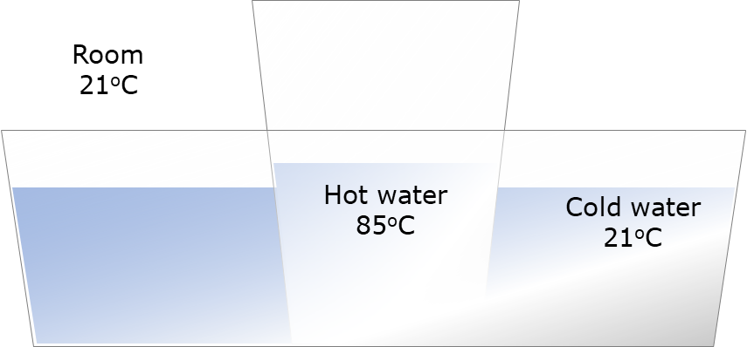

What do you think will happen?
For each statement, tick (✓) one column to show what you think.
Statements |  | I am sure this is right | I think this is right | I think this is wrong | I am sure this is wrong
A | The temperature of the hot water goes down
B | The temperature of the cold water goes up
C | After a long time the temperature of all the water is at the same temperature as the room
D | The temperature of the room goes up a tiny bit

Physics > Big idea PMA: Matter > Topic PMA1: Heating and cooling > Key concept PMA1.2: Heating and cooling
Diagnostic question
Just cool?

Overview
Learning focus: | If two objects at different temperatures are in contact, energy will move spontaneously from the object at the higher temperature to the object at the lower temperature.
Observable learning outcome: | Describe how the temperature of hot water changes as it cools
Question type: | Confidence grid
Key words: | Temperature, transfer, dissipation

What does the research say?
Students have a large store of everyday experiences of things heating or cooling, from which they will have developed ideas about these processes. Many however will not have formed a clear general (and scientific) understanding that they can apply to new situations. (Millar, 2011)
The situation shown in this question has a range of possible explanations. Some of these reveal misunderstandings that need to be overcome in order that students develop a scientific understanding of dispersion and of conservation of energy.
Ways to use this question
Students should complete the confidence grid individually. This could be a pencil and paper exercise, or you could use an electronic ‘voting system’ or mini white boards and the PowerPoint presentation.
If there is a range of answers, you may choose to respond through structured class discussion. Ask one student to explain why they gave the answer they did; ask another student to explain why they agree with them; ask another to explain why they disagree, and so on. This sort of discussion gives students the opportunity to explore their thinking and for you to really understand their learning needs.
Differentiation
You may choose to read the questions to the class, so that everyone can focus on the science. In some situations it may be more appropriate for a teaching assistant to read for one or two students.
Expected answers
All four statements are correct, although if you choose to carry out the investigation it is likely to prove impossible to measure a noticeable change in the room temperature for a range of reasons.

How to respond - what next?
Most students will recognise from their own experience that the temperature of the hot water decreases and that of the cold water increases.
The idea that the all the water ends up at the same temperature as the room may also be familiar to students, but this is less obvious. For this to happen energy must have been transferred from the water and into the air. This is called dissipation.
The mechanism for dissipation is the transfer of energy by collision between the water (or glass) particles with the air particles, which results in the air particles moving more quickly and the water particles moving more slowly.
The temperature of the air increases by a tiny amount because the air particles now have a slightly higher average speed (strictly speaking a higher average amount of energy in the kinetic store of each particle). As there is so much air the average speed of particles barely increases and the increase in temperature will be very hard to detect.
A significant number of students will describe energy (or ‘heat’) flowing into the air as if it is some sort of fluid. This is a common misunderstanding and it is important to emphasise that the change in temperature is due to the motion of particles and not the transfer of any ‘substance’.
If students have misunderstandings about how the temperature of hot (or warm) objects cool to the temperature of their surroundings, it can help to carry out a practical investigation to measure what happens. Discussing the reasons for the results can help develop a scientific understanding of what happens when things cool, and how energy in a thermal store often dissipates into the surroundings.
The following BEST ‘response activity’ could be used in follow-up to this diagnostic question:
- Response activity: Cooling curve
Acknowledgments
Developed by Peter Fairhurst (UYSEG), from an idea in Teaching Secondary Physics (Millar, 2011).
Images: Peter Fairhurst (UYSEG).
References
Millar, R. (2011). Energy. In Sang, D. (ed.) Teaching Secondary Physics. London: Hodder Education.

